WESTERN MICHIGAN UNIVERSITY
COLLEGE OF ENGINEERING AND APPLIED SCIENCES
CS 5821 MACHINE LEARNING
FINAL PROJECT
FALL 2023



Title: Predicting Non-Motorized Severe Crash Occurrence in Incidents Involving Vehicle-Pedestrian/Cyclist
Team Names: Sia Mwende and Digvijay Bhagat
Deadline: November 29^{th,} 2023, 11:59 pm

Introduction
In recent years, there has been an increasing amount of interest in non-motorized safety in U.S. cities. Non-motorized transportation includes all forms of travel that require not an engine or motor for movement. It includes walking, bicycling, and use of small-wheeled transportation such as skates, skateboards, and scooters. Non-motorized travel is inexpensive, environmentally friendly, and a healthy mode of transportation for short trips (such as the first and last mile) when used instead of automobiles (Mat Yazid et al., 2011). Despite the number of benefits associated with non-motorized modes of transportation, there are safety concerns and issues. Pedestrians and cyclists usually move at a significantly lower speed and have a smaller mass than vehicles. The severity of a road crash is predominantly determined by the kinetic forces arising from variations in the mass and speed of different elements involved in a crash. Due to this, pedestrians are more prone to serious injuries and fatalities during a crash compared to drivers and/or vehicle occupants (Zegeer & Bushell, 2012). This study predicted the occurrence of severe crashes (fatal or incapacitating injury) in non-motorized (pedestrian and cyclist) crashes.

Methodology

Data Description
This study used Michigan non-motorized crashes from 2009 to 2021. A total of 51,914 non-motorized crashes were used in the analysis, out of those 56% (29,072) involved pedestrians while 44% (22,842) involved cyclists. The dataset consisted of roadway features, non-motorized characteristics, and environmental characteristics as illustrated in Figure 1. The dataset contains 16 predictor variables with one binary target variable.
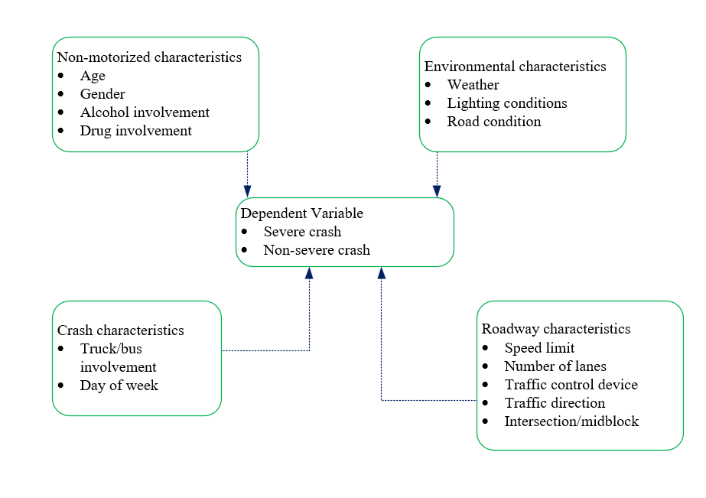
Figure 1: Variables in the study

Data Pre-processing
Data pre-processing was done after the dataset was imported into R Studio. Descriptive statistics of the variables were prepared to understand the data as shown in Table 1. Table 1 shows that a higher proportion of severe crashes occur on weekdays (73%), on stop or yield controlled (48%), at midblock locations (61%) and on undivided roadway (75%), and involving male pedestrian/cyclist (69%).
Table 1: Descriptive statistics of the data
 | Non-severe Injury |  | Severe Injury
Variable | Count | Percent | Count | Percent
Day of the week
Weekday | 33700 | 79% | 6755 | 73%
Weekend | 8997 | 21% | 2462 | 27%
Weather
Clear/Cloudy | 37584 | 88% | 7880 | 86%
Other | 5085 | 12% | 1333 | 14%
Lighting Condition
Dark | 11076 | 26% | 4412 | 48%
Dawn Dusk | 1988 | 5% | 405 | 4%
Daylight | 29453 | 69% | 4372 | 48%
Alcohol
No | 40434 | 95% | 7553 | 82%
Yes | 2263 | 5% | 1664 | 18%
Drug
No | 42412 | 99% | 8633 | 94%
Yes | 285 | 1% | 584 | 6%
Traffic signal
None | 8302 | 21% | 2743 | 33%
Traffic Signal | 11192 | 29% | 1641 | 20%
Stop/yield sign | 19138 | 50% | 4009 | 48%
Relation to the road
On road | 34876 | 82% | 7770 | 84%
Other | 7821 | 18% | 1447 | 16%
Road condition
Dry | 34632 | 81% | 7154 | 78%
Ice/snow/Wet | 8065 | 19% | 2063 | 22%
Number of lanes
<2 | 24920 | 58% | 4783 | 52%
>=3 | 17777 | 42% | 4434 | 48%
Truck involvement
No | 42120 | 99% | 8854 | 96%
Yes | 577 | 1% | 363 | 4%
Location
Midblock | 19949 | 47% | 5594 | 61%
Intersection | 22748 | 53% | 3623 | 39%
Direction of traffic
Non traffic | 3570 | 9% | 627 | 7%
Divided | 5319 | 13% | 1665 | 18%
Not physically separated | 32892 | 79% | 6760 | 75%
Gender
Female | 13267 | 32% | 2841 | 31%
Male | 28400 | 68% | 6314 | 69%
Age
Young | 12673 | 30% | 1997 | 22%
Adult | 22224 | 52% | 5444 | 59%
Elder | 7800 | 18% | 1776 | 19%
Speed limit (mph)
0-25 | 18197 | 43% | 2249 | 24%
30-50 | 19087 | 45% | 4757 | 52%
55-70 | 5410 | 13% | 2211 | 24%

All variables were categorical variables and missing rows were removed. Data was split into train data (80%) and test data (20%). Most machine learning classification models assume an even distribution of observations among different classes. Like other crash datasets, our data have unequal class samples. Dealing with an imbalanced dataset in model training causes bias towards the majority class. Therefore, the ROSE (Random Over-Sampling Examples) package was utilized in R which deals with binary classification problems in the presence of imbalanced classes. It generates synthetic balanced samples, which can strengthen the subsequent estimation of any binary classifier. Only the training data was oversampled using the ROSE package, the test data wasn’t so as to test real-world data.
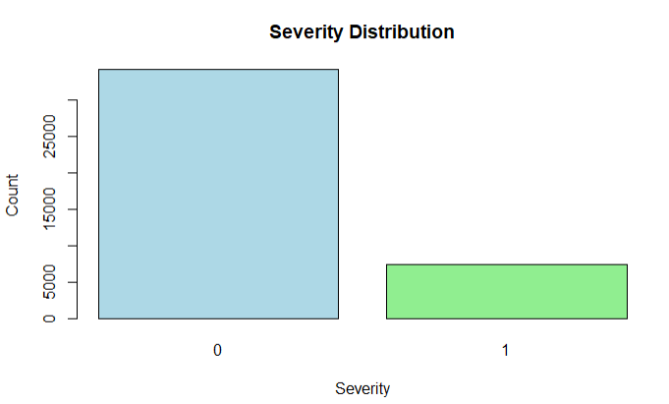 | 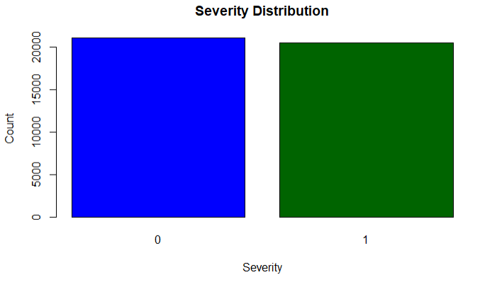
Before | After
Figure 2: Data Balancing

Feature Selection
Feature selection is important to ensure that the model doesn’t undergo overfitting by eliminating irrelevant features and also to improve the accuracy of the model (James et al., 2021). In this study, forward stepwise selection, backward stepwise selection, and LASSO regularization. Both forward stepwise and backward stepwise had similar variables with similar AIC values. Two variables were excluded which are weather and road conditions. LASSO regularization was also performed since it has the ability to reduce the coefficients of some variables to zero, however, the analysis yielded a low AUC value (0.53) and hence was assumed not feasible for this analysis.

Machine Learning Algorithms
Logistic Regression (LR) is a statistical method that elucidates the relationship between a binary outcome variable and one or more independent variables. In a binary logistic regression, let variable Y be the dependent variable of the crash severity. For instance, Y_{i}= 1 if the non-motorized crash was severe in an observation i while Yi = 0 if the non-motorized crash was not severe. Variables X= (X1, X2, ……., Xk) is the set of explanatory variables which in this case are discrete. The probability P_{i} can be expressed as an inverse logistic function of a vector X_{i} of the explanatory variables as
$$Pi=\frac{1}{1+e^{X_{i}β}}$$
The Random Forest (RF) model comprises a set of decision trees. In this supervised machine learning algorithm, numerous decision trees are created randomly, and their outputs are combined to produce a unified prediction. The model utilizes a confidence vote strategy from multiple decision trees. Unlike traditional classification tree methods, which are susceptible to overfitting risks arising from anomalies in the data, Random Forest addresses this issue by pruning uncorrelated trees and constraining the growth of unbiased error.
Another algorithm adopted in this study is the Extreme Gradient Boosting (XGBoost) model. During the training process of this model, trees are generated sequentially, with a focus on minimizing errors from previous trees. The ultimate model prediction is achieved by aggregating the contributions of all the newly constructed trees. This parallel processing algorithm is adept at handling intricate nonlinear relationships between features, ensuring reliable prediction accuracy and high-speed performance.
Parameter optimization is important in the tree-based methods; therefore cross-validation was used for hyper-parameter tuning using randomized search.

Evaluation Performance
The area under the receiver operating characteristic (ROC) curve (AUC) was employed due to the limitations of accuracy, precision, and recall, as they can be sensitive to variations in class distribution. The AUC metric, also referred to as the ROC or global classifier performance metric, is a widely employed ranking evaluation technique. It assesses the overall performance of diverse classification schemes, offering a robust measure that mitigates the impact of changes in class distribution (Hanafy & Ming, 2021).

Results Discussion
Figure 3 shows the AUROC for the XGBoost classifier (AUROC= 0.701) is higher than that of the logistic regression (AUROC=0.645) and RF Classifier (AUROC=0.651) on the test dataset. Meaning, the XGBoost classifier showed the ability to classify the non-motorized severe crash from non-severe crash with higher precision than the RF classifier. Based on this, XGBoost classifier was adopted for feature importance analysis.
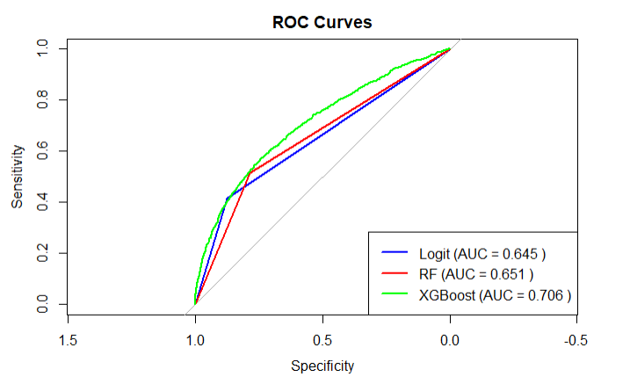
Figure 3: ROC (Logistic, RF, and XGBoost)

Feature Importance Analysis
This study employed the use of the “iml” package in R to understand the most important variables in the severity of non-motorized crashes from the XGBoost model. Figure 4 shows that the most important variable is speed which is expected since with higher speed likely there will be more severe crashes. In Figure 4, gain is the average contribution of the feature to the model across all trees. The higher the value, the more important the feature in contributing to the model. Other variables include lighting conditions, alcohol involvement, and drug involvement.
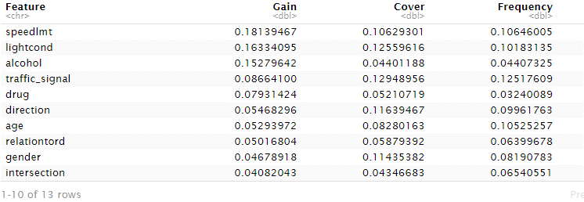
Figure 4: Relative importance of variables

References
Hanafy, M., & Ming, R. (2021). Machine learning approaches for auto insurance big data. Risks, 9(2), 1–23. https://doi.org/10.3390/risks9020042
James, G., Witten, D., Hastie, T., & Tibshirani, R. (2021). An Introduction to Statistical Learning with Applications in R Second Edition.
Mat Yazid, M. R., Ismail, R., & Atiq, R. (2011). The use of non-motorized for sustainable transportation in Malaysia. Procedia Engineering, 20, 125–134. https://doi.org/10.1016/j.proeng.2011.11.147
Zegeer, C. V., & Bushell, M. (2012). Pedestrian crash trends and potential countermeasures from around the world. Accident Analysis and Prevention, 44(1), 3–11. https://doi.org/10.1016/j.aap.2010.12.007

